Block Diagram



**TC_03**

**YJ Ha, Catherine Larson, Cameron Smith, Julie Van Kirk**

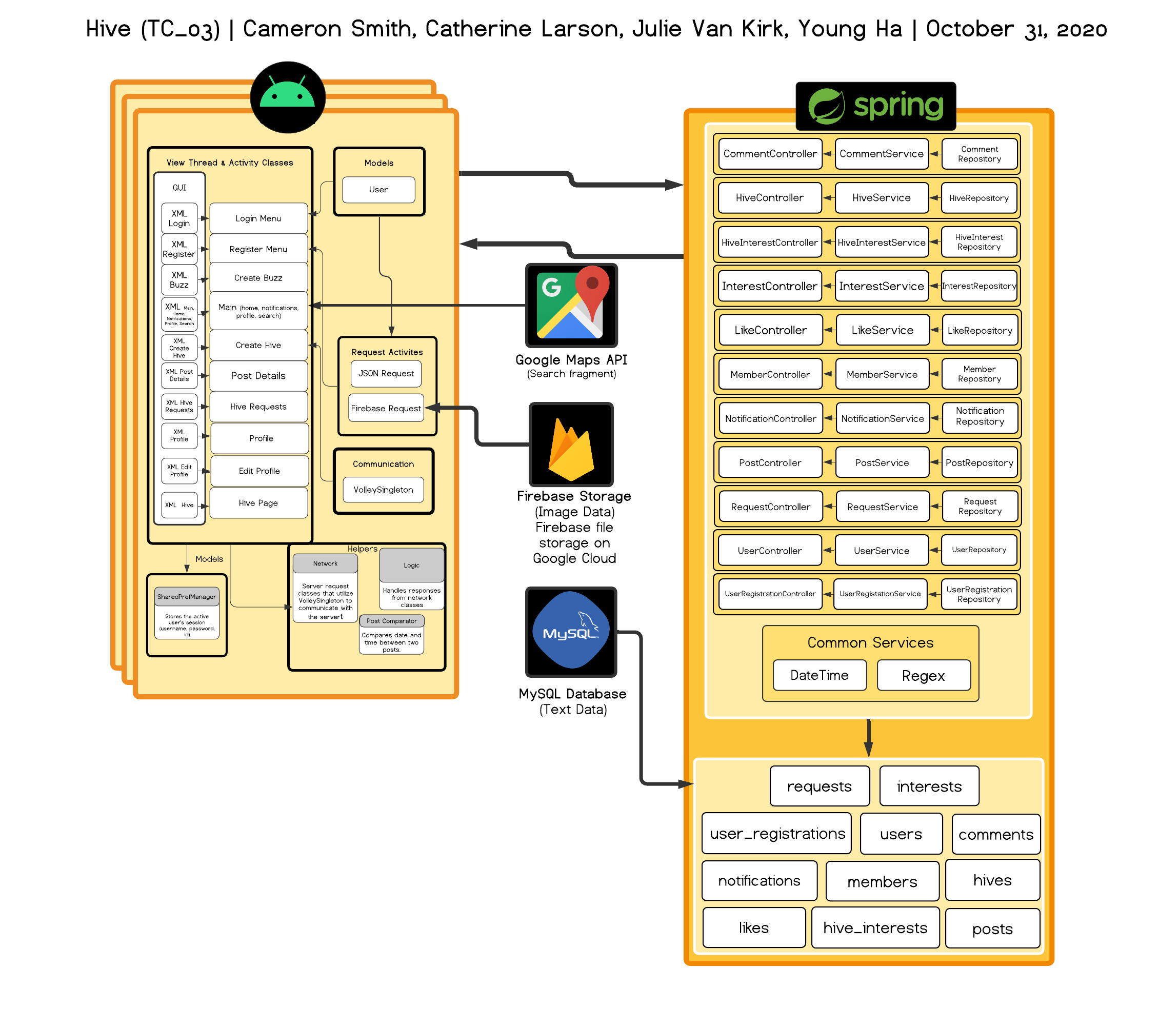

**Design Description**

**Android User GUI**

The Android application will have a thread related to (existing within) our Activity classes (10 in total). Hive will utilize these different activity classes (listed within the “View Thread and Activity Classes” on Page 2). Each activity class will have linked XML files which contain the styling or UI design for each page. The Main activity holds multiple fragments (home, search, notifications, profile) which houses an XML file for each fragment as well. Each activity class will have logic and network interfaces/classes which deal with displaying information and handling/creating server requests, respectively.

**Android Communication**

The Android application utilizes the VolleySingleton class to handle requests to the server. Each activity and fragment calls this in their server request helper class.

**Android Helpers**

To make the code more modular, each activity and fragment have a logic and network class. The network classes are what make the requests using VolleySingleton, and the logic handles the responses from those requests as well as other logic such as data validity checks. The PostComparator helper class is used in the home fragment to sort posts chronologically.

**Android Request Activities**

Through Android Volley and using JSON objects/responses, the Android application will communicate with the server to gather information parsed by the backend database -- all of which occurs in each Activity’s respective Network/Logic interfaces/classes.

For images, Hive will utilize the Firebase Storage application to store uploaded images which can be retrieved and displayed (requested); we also used Glide functions to ease this process.

**Android Models**

The User model, which depends on the activities, holds variables which store usernames, passwords, etc. and getter functions for those values. The SharedPrefManager holds the current User’s session information that can be accessed globally through instances of the SharedPrefManager object!

**SpringBoot Entities**

Spring boot contains our entities which each include a model, repository, service, and controller. We have entities for Hives, HiveInterests, Interests, Members, Users, UserRegistrations, Posts, Comments, Likes, Requests, and Notifications. Spring boot handles requests from our front end by creating/managing our entities in the MySQL database.

**SpringBoot Common Services**

The two common services used on the SpringBoot side are the DateTime and Regex classes. The DateTime class has a static method called getCurrentDateTime which is used in multiple models to get the current date in a format that is consistent throughout the app. The Regex class has a method called getUserNamesMentionedInText which given a String of text will return an ArrayList of username strings that were @ mentioned in the text.

